April 2025
Editor: Robb KC9NNT
Amateur Radio Saves Lives
SEMO Amateur Radio Association KC0UYN POBox 1454, Poplar Bluff, MO 63902

President, Dillon KD0PFQ; Vice President, Greg KC9WVR; Secretary, Mike KE0PEP; Treasurer Todd KO4RKC.
Trustees: Robb, KC9NNT, Russell KF5EPD and Ron KF0HMC
SEMOARA73@GMAIL.COM SemoHams.net

We still have tickets available for the raffle.

Huge thanks to Dillon KD0PFQ for his tireless emergency communications during the recent tornadic weather. Dillon took the bull by the horns and ran the EMCOMM net the four nights we enjoyed the storms.

We have set up a testing for the 26 April preparation Fair at the Church of Jesus Christ of Latter-day Saints, 2414 Katy Lane. See the flier at the end of the newsletter for more information.

Field Day is coming up soon. Watch for details.

Join us for breakfast this Saturday, 12 April, at Hardees. 8:30 am. Buy your own and enjoy the free conversation.

A Parks On The Air (POTA) event is in the planning stages. This may become a semimonthly event to get more hams on the air.

Special event amateur radio station K8L will celebrate National Library Week 2025, operating from Youngstown, Ohio, between April 11, 1600 UTC (12 PM EDT) and April 13, 1600 UTC (12 PM EDT). Operation will be from various libraries in the Youngstown area, mainly on 20 and 40 meters, both SSB & FT8. A QSL card is available by sending a request to K8L, 239 Elvira Ct. McDonald, OH 44437. More information is available at QRZ.com www.qrz.com/db/K8L.

The 910 repeater is on echo link. So you can check in from anywhere in the world. Program KD0PFQ-R into your echo link app.

March 2024 A.R.E.S. Report for Butler County: Check ins (QNI): 71. Traffic passed (QTC): 9. Emergency power 5. Storm watcher sessions: 2, ARES Members:9

FCC Initiates Broad Inquiry on Rules to Delete or Amend

In a Public Notice titled “In Re: Delete, Delete, Delete,” issued on March 12, 2025, the FCC is soliciting public input on any FCC rules in any service that members of the public believe should be deleted or modified “for the purpose of alleviating unnecessary regulatory burdens.” This is the latest in a series of similar proceedings going back to 1996, when the Communications Act was amended to require the FCC to periodically review its rules. A PDF of the FCC Public Notice is available here: https://docs.fcc.gov/public/attachments/DA-25-219A1.pdf.
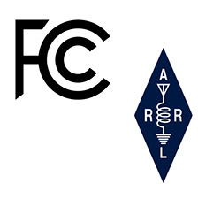

The annual Armed Forces Day (AFD) Crossband Test, hosted by the Department of Defense, is scheduled for Saturday May 10, 2025. The event will test two-way communications between military stations and amateur radio operators as authorized by the Federal Communications Commission in Title 47 of the Code of Federal Regulations 47 CFR 97.111. The tests provide opportunities — and challenges — for operators to test their individual technical skills in a controlled scenario that will not impact public or private communications. The annual DOD message will be transmitted via RTTY on 14,667 kHz at 1400 and 2000 UTC. Military stations will transmit on selected military frequencies and announce the specific amateur radio service frequencies that will be monitored. All scheduled times will be in UTC, and all scheduled frequencies will be upper sideband (USB), unless otherwise noted. For more than 50 years, military and amateur stations have taken part in this event. Information on frequencies, times, and other technical information can be found at DoD MARS - Armed Forces Day. A QSL card will be available in May after the test at www.usarmymars.org/home.

Listen to HF radio on your computer: http://na5b.com:8901/

Training for EMCOMM is available at: http://www.arrl.org/emergency-communications-training

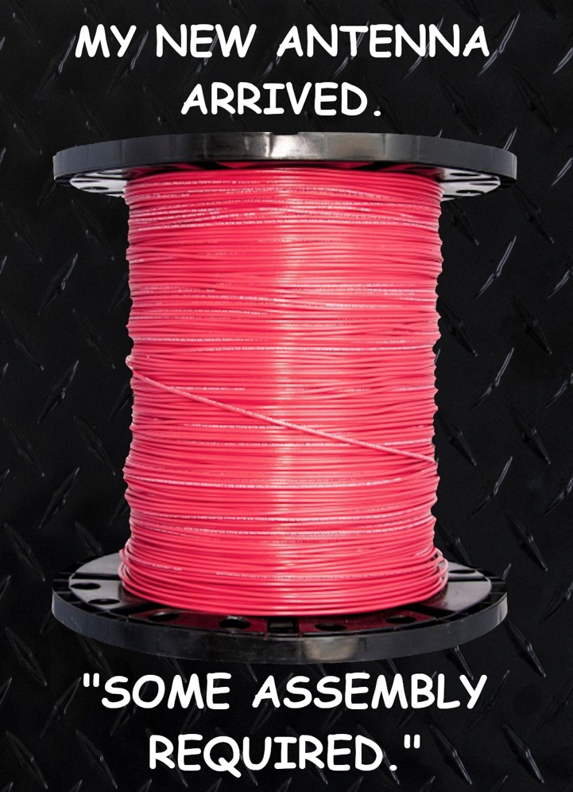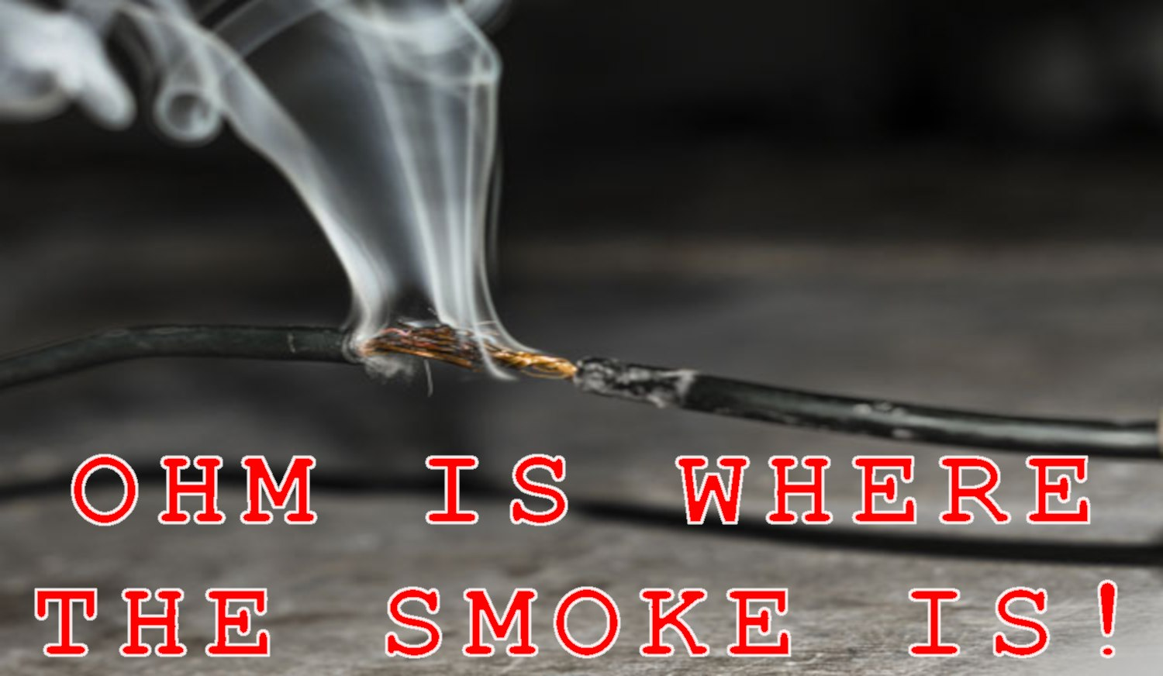

Test your memory: T3B06
What is the formula for converting frequency to approximate wavelength in meters?
A. Wavelength in meters equals frequency in hertz multiplied by 300
B. Wavelength in meters equals frequency in hertz divided by 300
C. Wavelength in meters equals frequency in megahertz divided by 300
D. Wavelength in meters equals 300 divided by frequency in megahertz
Answer at end of newsletter.

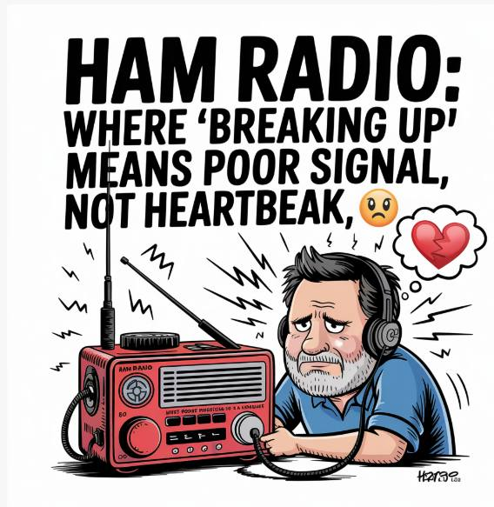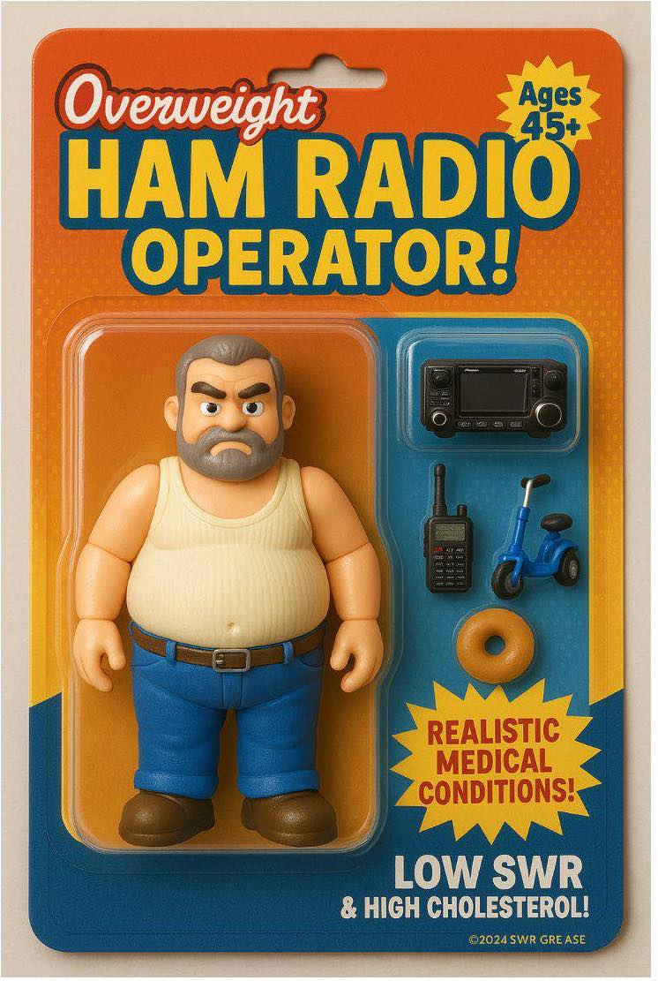

Call for QST Articles for the July 2025 Special Issue on EmComm

Every July, QST, the membership journal of ARRL, publishes a special issue with an EmComm focus. This issue is a perfect opportunity for your ARES group to share your experiences doing exercises and drills, as well as participating in responses, so other groups will benefit from your experience. Here’s what QST is looking for:

--1,200 to 1,800 words--Tell the story of your participation in an exercise or response with a “how-to” angle. For example, if your club designed an exercise, talk about the rationale that led to the choice of the exercise scenario and parameters.

--2-5 high-resolution images–Include captions that explain what’s happening in the photos, the names and call signs of any hams pictured, and the name (and call sign, if applicable) of the person who took each photo.

Send the manuscript and photos to qst@arrl.org by May 1.

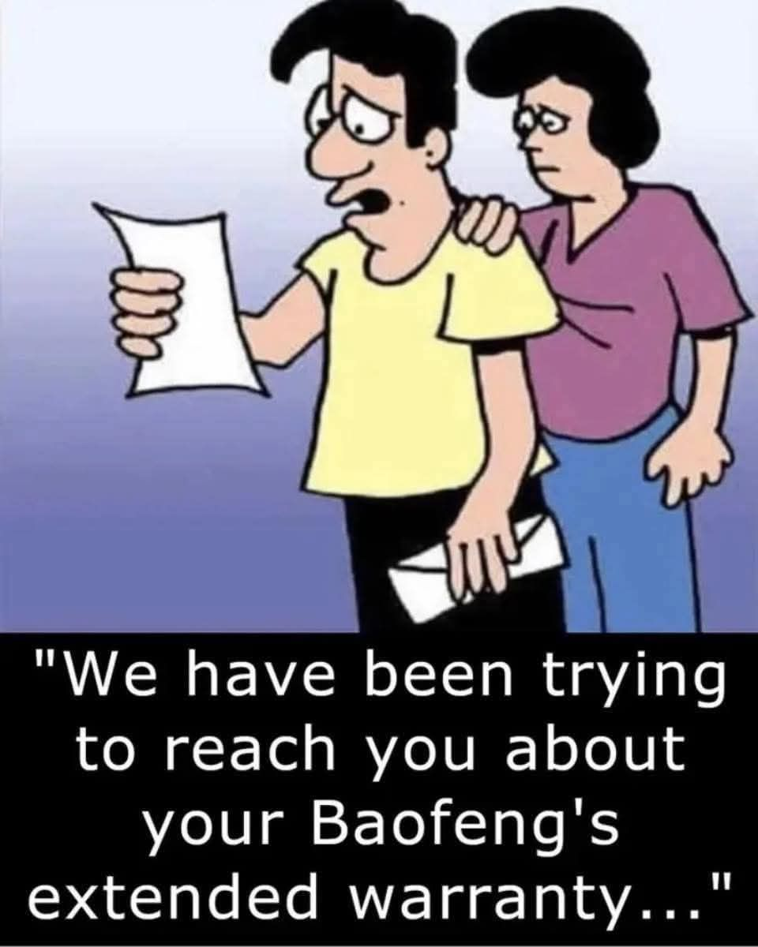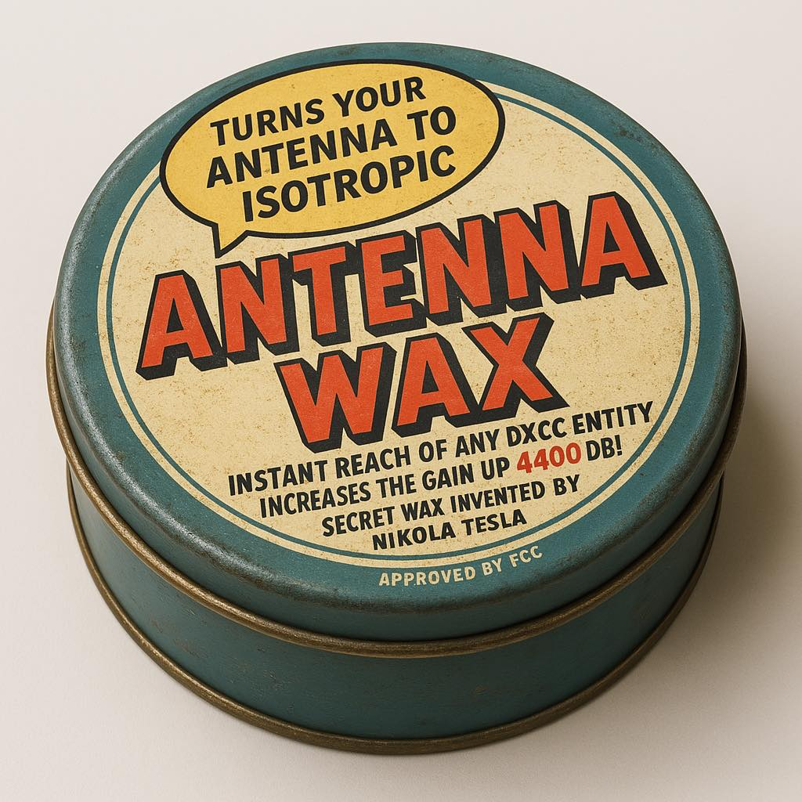
Area Nets (All times central USA time zone unless otherwise indicated)

Monday
Stoddard County ARES net 2nd Monday monthly, 6 pm 147.150+ 100 pl
The Missouri ARES® District E Training and Traffic net 7 pm on 147.330 pl tone 100.0 (Bloomfield)
Missouri DMR Net 7 pm on talk group 31291
SEMO ARA Butler Co ARES net at 8 pm on 146.910 pl 100.0
Missouri DMR net 8pm TG 3129

Tuesday
Piedmont Net at 7 pm on 147.375 pl 100
Current River net 7:30 pm on 146.865 pl 100

Wednesday
SEMO ARA Learn Morse Code Net about 5:45 pm on 146.495
SEMO ARA Butler Co ARES check-in net at 7:00 pm on 145.350 pl 100.0
SEMO DMR rag chew 6:30pm talk group 31295

Thursday
The Missouri ARES® District E Training and Traffic net 7 pm on the 146.910 pl tone 100.0 (Poplar Bluff)
Doniphan net 7:30 pm on 146.865 pl 100
Greenville Net 8 pm on 145.230 pl 123
Bootheel ARC, Kennett Net 8 pm on 146.985 pl 100
Digital Thursday net about 8:15 pm on 145.13 & 145.31(no pl tone needed)

Friday
SEMO ARA Learn Morse Code Net about 5:30 pm on 146.495

Sunday
The PBW-Net humanitarian 8 pm on simplex 146.495
SEMO ARA Learn Morse Code Net about 8:15 pm on 146.495
SEMO Emergency Net 7 pm first Sunday each month 28.400 USB

FORMAL TRAFFIC, TRAINING or ROLL CALL NETS (must have a general or higher license)

Missouri Traffic Net nightly 5:30 pm 3.963 (5 pm winter hours)
Missouri Emergency Services Net 2 pm Sunday on 3.963 MHz+/- or 7.263 MHz +/-
Illinois Sideband Traffic Net nightly at 6 pm on 3.905
Illinois ARES net First and Third Sunday 4:30pm 3.905
Arkansas Razorback Traffic net nightly 6:30pm 3.987.5
Country Cousins Net. Daily 9:00 pm 3.970
Ham Butchers. weekdays 11:30 am. 7.280
Frisco Net. Saturday. 9 am 3.922 or 3.915 depending on conditions
Kadiddlehoppers daily (except Sunday) 12:30 pm 7.253.5
Hurricane watch net on 7.268.00 MHz

NOAA emergency radio frequencies: 163.275, 162.55, 162.525, 162.50, 162.475, 162.45, 162.425, 162.40

Emergency radio frequencies you may need at one time or another:
  - – Military national disaster preparedness frequency
  - -163.4875 – National Guard emergency communications frequency
  - -156.80 – International maritime distress channel
156.75 – International maritime weather alerts
155.475 – Emergency communications for police
155.160 – Used by various agencies during search and rescue operations
154.295 – Used by firefighters during emergencies
154.28 – Used by firefighters during emergencies
154.265 – Used by firefighters during emergencies
138.225 – Disaster relief channel used by FEMA
121.50 – International frequency for aeronautical emergencies
47.42 – Nationwide Red Cross channel during humanitarian aid missions
39.46 – Inter-department emergency communications by police
34.90 – Nationwide National Guard frequency during emergencies

One way to communicate with family members during an emergency situation when cellphones are not working is through CB (Citizens’ Band) radio. There are 40 separate channels that CB radios operate on. The only one to avoid is Channel 9, which is reserved for the Emergency/REACT channel.
One thing to keep in mind is that your conversations while using CB radio will not be secure. Bad guys could be on the same channel at the same time.
Among the other channels are:
Channel 37 – Unofficial Prepper 37 (USB)
Channel 36 – Unofficial Survivalist network
Channel 19 – Used by truckers headed east or west
Channel 17 – Used by truckers headed north or south
Channel 13 – Typically used within campgrounds and marine areas
Channel 4 – Unofficial American Preppers Network
Channel 3 – Unofficial Prepper CB Network
Plan for emergencies at ready.gov and providentliving.org

As always, we need help with our numerous committees. Please contact a committee chair to join, or Dillon KD0PFQ (club president) to chair a committee (or start one).

Do you have an item for the News Letter? Email it to KC9NNT@ARRL.NET

Answer to test your memory : D. Wavelength in meters equals 300 divided by frequency in megahertz

- 