SEMO ARA NEWSLETTER
August 2023
Editor: Robb KC9NNT
Amateur Radio Saves Lives
SEMO Amateur Radio Association KC0UYN POBox 1454, Poplar Bluff, MO 63902

President, GregKC9WVR; Vice President, John KF0KHE;; Secretary, Mike KE0PEP; Treasurer Gary KD0FWH.

A huge thanks to Robbie Myers KE0FCV for providing the club with a first aid kit for the trailer, along with a back up charger and emergency radio.
ARRL Audio News. Listen to ARRL Audio News, available every Friday. ARRL Audio News is a summary of the week's top news stories in the world of amateur radio and ARRL, along with interviews and other features. The On the Air podcast is available on iTunes (iOS) and Stitcher (Android). The On the Air podcast and ARRL Audio News are also on blubrry -- On the Air | ARRL Audio News.
Win a $500 shopping spree at a local Poplar Bluff Outdoor store in our club fund raiser raffle. (If you choose to spend it on a firearm, you need to pass the Federal Background Check.) Tickets available at $10 each and only 100 raffle tickets will be sold. See Greg KC9WVR for tickets. Get yours before they are all gone.

WARNING: There is a scam email going around that appears to be from ARRL. It is asking for gift cards. NO! Do not fall for it. ARRL does NOT ask for gift cards.

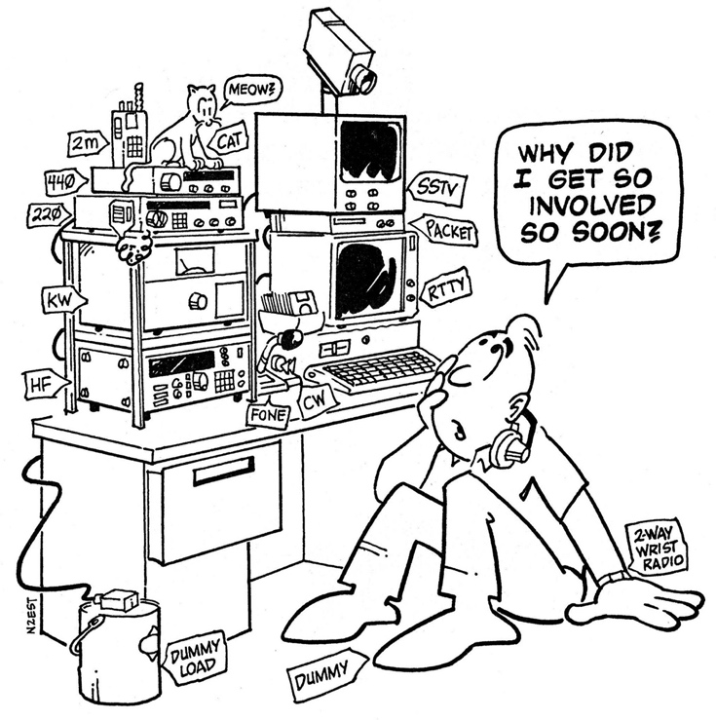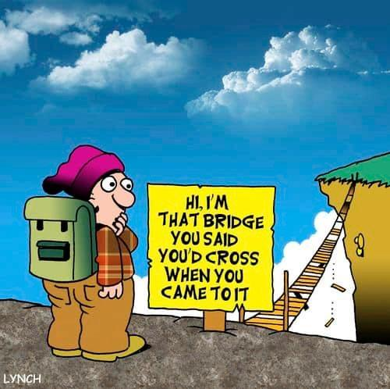

There will be a special election at the September meeting for the office of Vice President of the SEMO ARA. All members in good standing are invited to be nominated and run for the office.

Listen to HF radio on your computer: http://kb0fxkiwisdr.hopto.org:8073/

July A.R.E.S. Report for Butler County: Check ins: 54. Traffic passed: 11. Emergency power 4

RadioMail brings Winlink to iOS devices -- The Winlink Development Team has announced the release of RadioMail, "a new client app for the iPhone by Island Magic Co. of Kaua'i, Hawaii. With RadioMail, you can easily send and receive Winlink emails via telnet or pair with modems to exchange emails over the air." There is a $14.99 purchase price for this app. (Winlink/RadioMail is the emergency communication mode for the Red Cross organization.)

Amateur radio has earned praise for providing emergency communication in response to disasters. But it should not be taken for granted. A strategy is needed to meet tomorrow's emergency communication needs. That strategy should guide regulatory policy and technology development to make amateur radio hospitals' go-to emergency communication solution and give young people an exciting new outlet for their technical skills and eagerness to serve their local communities. -- Ira Brodsky, KC9TC, St. Louis, Missouri

Test your memory: T6B09 What are the names for the electrodes of a diode?
- A. Plus and minus
- B. Source and drain
- C. Anode and cathode
- D. Gate and base
Answer at end of newsletter.

IF you have moved since your FCC Amateur Radio License was issued, please put in a change of address with ARRL or the FCC. You can change your address for free at FFC.gov

National Sunflower Day is August 15, 2023, and the ARRL Kansas Section will be hosting a Sunflower Net. The Sunflower Linked System is a multimode linked system in Kansas and the special event call sign is W0S. Stations are encouraged to check into the Sunflower Net using one of the connectors listed at www.sunflowernet.us. Those connections are available on Allstar, Hamshack Hotline, EchoLink, digital mobile radio (DMR), Digital Smart Technology for Amateur Radio (D-STAR), System Fusion, Project 25 (P25), or open-source amateur radio M17. Lloyd Colston, KC5FM, one of the event managers, said the sunflower is the state flower of Kansas, and more information about its observance and history is available at the National Sunflower Day website or at State Symbols USA.

Slow-Scan TV Experiment with ARRL Planned for Amateur Radio on the International Space Station. Amateur Radio on the International Space Starion (ARISS), in collaboration with ARRL, plans to carry out a special slow-scan TV (SSTV) experiment from the ISS on Wednesday, July 26, 2023. During the event, the Columbus Module Repeater, transmitting at 437.800 MHz, will carry a message to be received by teachers attending the ARRL Teachers Institute on Wireless Technology professional development class. The pass will be over the Mid-Atlantic and New England area, with transmissions scheduled to begin at 20:05 UTC (16:05 ET) and end at 20:20 UTC (16:20 ET). If necessary, a backup window is scheduled from 21:40 UTC (17:40 ET) to 21:55 UTC (17:55 ET).

The ARRL Board of Directors made the tough, but necessary, decision to increase the regular membership dues rate to $59 a year starting January 1, 2024 (see 2024 Dues Rates). Additionally, we have chosen to separate the printed, mailed magazine from regular membership. Members will be able to choose whether they want to add-on a print subscription to any of our magazines including QST, On the Air, QEX, and NCJ. All members will continue to have online, digital access to each of these four magazines and the digital archive as part of their regular membership benefits. A few months ago, ARRL sent out a survey to its members. Your feedback showed us the many benefits, services, and programs you use - from Logbook of The World, to the work done by the ARRL Lab to test equipment for product reviews. While our magazines topped the list of benefits, many of you also shared that your reading preferences have changed. Some of you prefer print, and increasingly members prefer digital. As a result, for those who prefer print, you will be able to subscribe to QST and/or On the Air magazine. Again, all members will continue to have access to the digital editions of all four ARRL magazines.

Free to ARRL members: Subscribe to the ARES Letter (monthly public service and emergency communications news), the ARRL Contest Update (biweekly contest newsletter), Division and Section news alerts and much more!
The 3rd annual Masonic Lodges on the Air (MLotA), an amateur radio special event, will occur on Saturday, September 23, 2023, from locations across the United States. The event is open to all amateur radio operators. The idea for the event grew from the realization that many Freemasons also have a love for amateur radio. The Fulton County Amateur Radio Club and Ohio's Fulton Lodge #248 first hosted the event in 2021. The mission is to promote fraternal bonds within the ranks for Free and Accepted Masonic lodges and its many amateur radio operators, who are also brothers in the fraternity while encouraging contact with amateur radio operators around the state, county and world. The event will take place from 10:00 AM - 6:00 PM ET, on 80 - 40 - 20 -15, and 10 meters SSB. Amateur radio participants are asked to honor all band plans, and all contacts must be on the phone portion of the bands. Stations may be contacted once on each band. Complete contest rules and more information can be found at cqmorelight.com/rules.

As always, we need help with our numerous committees. Please contact a committee chair to join, or Greg KC9WVR (club president) to chair a committee (or start one).

Please attend the Free Advice dutch treat breakfast Saturday after our SEMO ARA meeting. It’s at Hardees on Westwood Blvd at 8:30 am. Did I mention all advice is free!!

Amateur radio operators are needed for a real-world science experiment during upcoming solar eclipse events. Members of the Ham Radio Science Citizen Investigation (HamSCI) will be making radio contacts during the 2023 and 2024 North American eclipses and probing the Earth's ionosphere. The Solar Eclipse QSO Parties (SEQPs) are set to be fun and friendly with a competitive element, and all amateur radio operators and shortwave listeners are invited to participate. The upcoming eclipses (October 14, 2023, and April 8, 2024) provide unique opportunities to study interactions between the sun and the ionosphere. As participants and HamSCI members transmit, receive, and record signals across the radio spectrum during both eclipse events, valuable data will be created to test computer models of the ionosphere. Learn more at https://hamsci.org/projects. ARRL is a partner with HamSCI for the SEQP.

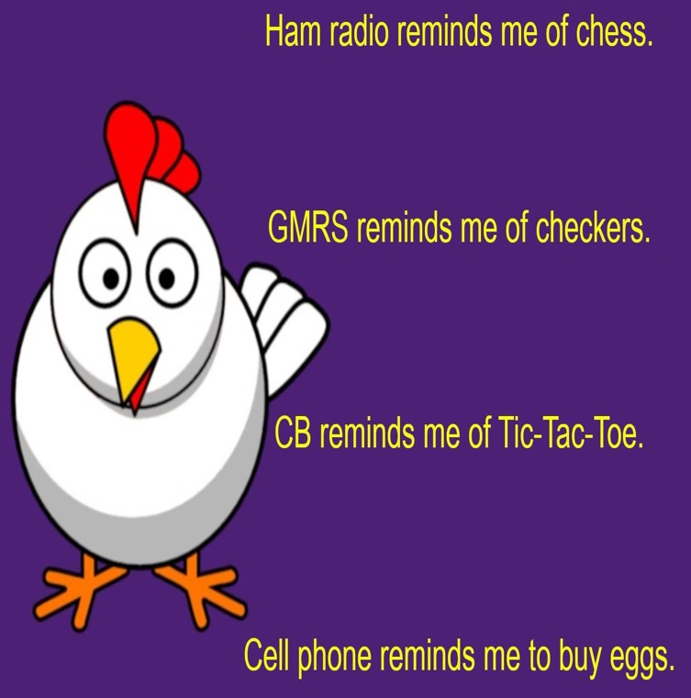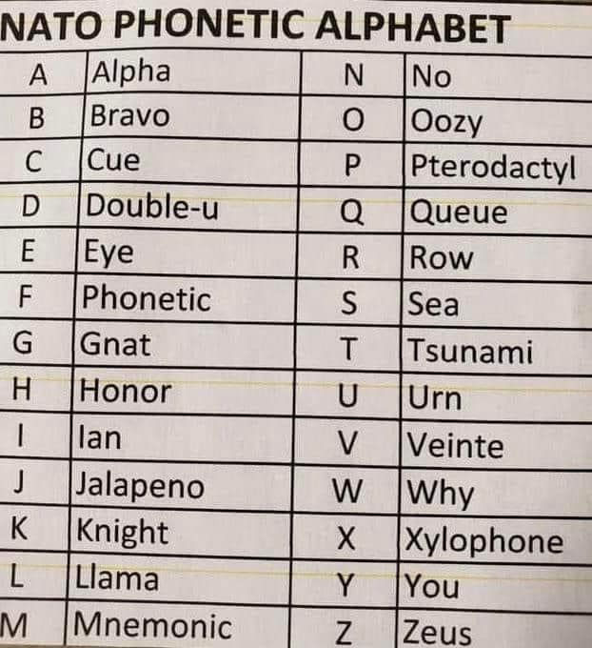

Remember our Ice Cream Social (dutch treat) at Burger King the 4th Tuesday evening each month at 6:30pm.

Do you have a fun idea for a club contest or activity? Bring it up at the next meeting and we’ll discuss it. Of course, you have to attend to do so.
Download the ARES® manual at: www.arrl.org/files/file/Public%20Service/ARES/ARESmanual2015.pdf

Training for EMCOMM is available at: http://www.arrl.org/emergency-communications-training

Area Nets (All times central USA time zone unless otherwise indicated)

Monday
Stoddard County ARES net 2nd Monday monthly, 6 pm 147.150+ 100 pl
The Missouri ARES® District E Training and Traffic net 7 pm on 147.330 pl tone 100.0 (Bloomfield)
Missouri DMR Net 7 pm on talk group 31291
SEMO ARA Butler Co ARES check-in net at 7:30 pm on 145.350 pl 100.0
Missouri DMR Net 7:30 pm on talk group 3129
SEMO ARA Butler Co ARES net at 8 pm on 146.910 pl 100.0
Missouri DMR net 8pm TG 3129

Tuesday
SEMO ARA Learn Morse Code Net about 5:30 pm on 146.495
Piedmont Net at 7 pm on 147.375 pl 100
Current River net 7:30 pm on 146.865 pl 100

Wednesday
SEMO DMR rag chew 6:30pm talk group 31295

Thursday
The Missouri ARES® District E Training and Traffic net 7 pm on the 146.910 pl tone 100.0 (Poplar Bluff)
Doniphan net 7:30 pm on 146.865 pl 100
Greenville Net 8 pm on 145.230 pl 123
Bootheel ARC, Kennett Net 8 pm on 146.985 pl 100
Digital Thursday net about 8:15 pm on 145.13 & 145.31(no pl tone needed)

Friday
SEMO ARA Learn Morse Code Net about 5:30 pm on 146.495

Sunday
The PBW-Net humanitarian 8 pm on simplex 146.495
SEMO ARA Learn Morse Code Net about 8:15 pm on 146.495
SEMO Emergency Net 7 pm first Sunday each month 28.400 USB

FORMAL TRAFFIC, TRAINING or ROLL CALL NETS (must have a general or higher license)

Missouri Traffic Net nightly 5:30 pm 3.963 (5 pm winter hours)
Missouri Emergency Services Net 2 pm Sunday on 3.963 MHz+/- or 7.263 MHz +/-
Illinois Sideband Traffic Net nightly at 6 pm on 3.905
Illinois ARES net First and Third Sunday 4:30pm 3.905
Arkansas Razorback Traffic net nightly 6:30pm 3.987.5
Country Cousins Net. Daily 9:00 pm 3.970
Ham Butchers. weekdays 11:30 am. 7.280
Frisco Net. Saturday. 9 am 3.922 or 3.915 depending on conditions
Kadiddlehoppers daily (except Sunday) 12:30 pm 7.253.5
Hurricane watch net on 7.268.00 MHz
NOAA emergency radio frequencies: 163.275, 162.55, 162.525, 162.50, 162.475, 162.45, 162.425, 162.40Emergency radio frequencies you may need at one time or another:
- 163.5125 – Military national disaster preparedness frequency
- 163.4875 – National Guard emergency communications frequency
- 156.80 – International maritime distress channel
- 156.75 – International maritime weather alerts
- 155.475 – Emergency communications for police
- 155.160 – Used by various agencies during search and rescue operations
- 154.295 – Used by firefighters during emergencies
- 154.28 – Used by firefighters during emergencies
- 154.265 – Used by firefighters during emergencies
- 138.225 – Disaster relief channel used by FEMA
- 121.50 – International frequency for aeronautical emergencies
- 47.42 – Nationwide Red Cross channel during humanitarian aid missions
- 39.46 – Inter-department emergency communications by police
- 34.90 – Nationwide National Guard frequency during emergencies

One way to communicate with family members during an emergency situation when cellphones are not working is through CB (Citizens’ Band) radio. No license is needed to send or receive communications. Combined with a family disaster plan, it will aid you greatly if cellphone towers stop working. There are 40 separate channels that CB radios operate on. The only one to avoid is Channel 9, which is reserved for the Emergency/REACT channel.
One thing to keep in mind is that your conversations while using CB radio will not be secure. Bad guys could be on the same channel at the same time.
Among the other channels are:
- Channel 37 – Unofficial Prepper 37 (USB)
- Channel 36 – Unofficial Survivalist network
- Channel 19 – Used by truckers headed east or west
- Channel 17 – Used by truckers headed north or south
- Channel 13 – Typically used within campgrounds and marine areas
- Channel 4 – Unofficial American Preppers Network
- Channel 3 – Unofficial Prepper CB Network

NOTEWORTHY WEBSITES
NWS SKYWARN SPOTTER TRAINING schedule weather.gov/pah/spottertraining
SEMO Amateur Radio Association SEMOHAMS.NET
Topographical Maps heywhatsthat.com
W0AVQ’s Repeater Overlay on Google Earth http://hamradio.w0avq.org/repeaters
ARRL Hamfest and Convention list arrl.org/hamfests/search
Ed’s (AD0WN) Tri-State Repeater list http://semoarc.com/nets.htm
SARA CLUB w9rnm.org
TRI STATE AMATEUR RADIO SOCIETY w9og.net
W9RY SOUTHERN IL. AMATEUR RADIO PAGE w9ry.com
TRI STATE AMATEUR RADIO SOCIETY w9og.net
CountyHunter.com for cw
Weather forecasting related Windy.com
Plan for emergencies at ready.gov and providentliving.org, emergency.cdc.gov, fema.gov, redcross.org/get-help/how-to-prepare-for-emergencies.html, savethechildren.org/us/what-we-do/us-programs/disaster-relief-in-america
We are in need of sponsors for our fund raisers. A sponsor may support us with gift certificates or monetarily. Talk to business owners you know and see if they are interested in helping the community by supporting SEMO ARA. They will be mentioned often in our newsletter and on our Facebook pages. We are open to ideas.

Join or Renew Today! All ARRL members can access digital editions of all four ARRL magazines: QST, On the Air, QEX, and NCJ.

Do you have an item for the News Letter? Email it to KC9NNT@ARRL.NET
- Answer to test your memory: C. Anode and cathode

