SEMO ARA NEWSLETTER
March 2023
Editor: Robb KC9NNT
Amateur Radio Saves Lives
SEMO Amateur Radio Association POBox 1454, Poplar Bluff, MO 63902

President, GregKC9WVR; Vice President, John KF0KHE;; Secretary, Mike KE0PEP; Treasurer Gary KD0FWH.

The 350 repeater is working thanks to Mark KC0SHD. Job well done, Mark!

March 18 at 9 am we are meeting at the fire house at US60 and T highway. We are going to pick up our section of the highway (US60) and enjoy each other’s company. All hands!

AT the March meeting, we tested 3 people and all three passed. Congrats to Kent KF0CIA, James KF0KBM, and Russell KF5EPD.

Amateur radio operators can sign up now to be a volunteer for the 2023 Boston Marathon. New volunteers can sign up here and, while the deadline is Friday, February 10, 2023, at 5:00 PM EST, the Boston Athletic Association is recommending having applications completed by Friday January 27, 2023. A step by step guide is available to help select amateur radio positions during the registration process. The Boston Marathon will run April 17, 2023.

We are missing the club gavel. If you have it, or know of it’s whereabouts, please help us find it.

There is a new ham club in town. The Ripley County Amateur Radio Club holds its meetings at 305 Plum Str. in Doniphan. More info to follow.

Listen to HF radio on your computer: http://kb0fxkiwisdr.hopto.org:8073/
The 6th Annual Amateur Radio Science Citizen Investigation (HamSCI) Workshop will be held March 17 - 18, 2023, in person at The University of Scranton and virtually via Zoom. The workshop is open to students and citizen scientists, and all amateur radio operators are invited to attend. The theme of the 2023 HamSCI workshop is "Forging Amateur-Professional Bonds." The primary objective is to bring together the amateur radio community and professional scientists. This year, the workshop will feature a working special event amateur radio station using the call sign W3USR. In-person participants can stop by the station to operate or learn about how an amateur radio station works. The Murgas Amateur Radio Club, K3YTL, is organizing and running the W3USR special event station. The 2023 HamSCI workshop is organized by The University of Scranton with generous financial support provided by the United States National Science Foundation and Amateur Radio Digital Communications. HamSCI is an officially recognized NASA citizen science project. Registration for the in-person workshop is now open. and will close on Monday, March 6, 2023. Virtual participation is free of charge. For more registration information visit HamSCI.
2023 Field Day is being planned. Robbie KE0TIL is heading up the effort. He is currently seeking a suitable place to hold the event. Several suggestions were made to him. If you would like to help with field day, contact Robbie.

The General - Class Element 3 Question Pool Errata has been released. The National Conference of Volunteer Examiner Coordinators, NCVEC, Question Pool Committee has released the latest errata for the 2023 - 2027 Element 3 General question pool, which goes into effect on July 1, 2023. Nine questions were modified (G1B01, G1C01, G1C02, G5C02, G7C10, G9B05, G9C09, G9D09, and G9D10) and two questions (G9C06 and G9D13) were withdrawn from use. The pool is available as a Microsoft Word document and PDF. These changes are reflected in the new General Pool download file, dated February 1, 2023.

Scouting Merit Badge: According to a Scouting magazine study of Merit Badges earned in 2022, Radio had the biggest jump. It is now the 81st most popular Merit Badge, up from being 98th in 2021. Trailing just behind it on the biggest gains list is the Electronics Merit Badge, which jumped 15 spots, from 80th to 65th. To earn the rank of Eagle Scout, members must earn 21 badges, 14 of which are standard. The Scout gets to choose the remaining badges based on personal interests.
Many Scouts take part in Jamboree on the Air, which is being held October 20 - 23, 2023.

Join or Renew Today! Eligible US-based members can elect to receive QST or On the Air magazine in print when they join ARRL or when they renew their membership. All members can access digital editions of all four ARRL magazines: QST, On the Air, QEX, and NCJ.

World Amateur Radio Day Theme: Human Security for All
The International Amateur Radio Union (IARU) announced that Human Security for All (HS4A) will be this year's theme of World Amateur Radio Day on April 18, 2023.
The day is being celebrated with a 2-week operating event occurring April 11 - 25. Special event stations will be operating from around the world, making two-way radio contacts to call attention to the HS4A campaign.
The concept of human security measures the security of an individual by things essential to one's well-being. This includes economics, food, health, the environment, personal factors, the community, and political factors.
Amateur radio is uniquely positioned to address those challenges by promoting technical knowledge, practical skills, innovative technology, and the deployment of backup systems at the community level that can be called upon in times of emergency.
IARU, a federation of the national amateur radio societies of over 150 countries worldwide, is the global advocate for amateur radio through its Sector Membership in the International Telecommunication Union, an agency of the U.N., and other activities.
The United Nations Trust Fund for Human Security and the World Academy of Art and Science are partnering with IARU in the campaign.
In a release, the partners wrote, "Amateur radio has repeatedly demonstrated its ability to address human security needs. It is a truly global communications medium comprising some three million radio enthusiasts connecting communities and the peoples of the world."
ARRL participates in World Amateur Radio Day each year. It was on this day in 1925 that the IARU was formed in Paris. ARRL co-founder Hiram Percy Maxim was its first president. For additional World Amateur Radio Day resources, visit http://www.arrl.org/world-amateur-radio-day.

Test your memory: T5D01
What formula is used to calculate current in a circuit?
A. I = E × R
B. I = E / R
C. I = E + R
D. I = E - R

Answer at end of newsletter.

Free of charge to ARRL members: Subscribe to the ARES Letter (monthly public service and emergency communications news), the ARRL Contest Update (biweekly contest newsletter), Division and Section news alerts and much more!

Do you have a fun idea for a club contest or activity? Bring it up at the next meeting and we’ll discuss it. Of course, you have to attend to do so.

IF you have moved since your FCC Amateur Radio License was issued, please put in a change of address with ARRL or the FCC. You can change your address for free at FFC.gov

Hurricane watch net on 7.268.00 MHz

As always, we need help with our numerous committees. Please contact a committee chair to join, or Greg KC9WVR (club president) to chair a committee (or start one).

Please attend the Free Advice dutch treat breakfast Saturday after our SEMO ARA meeting. It’s at Hardees on Westwood Blvd at 8:30 am. Did I mention all advice is free!!

A.R.E.S. Report for Butler County:

The Amateur Radio Emergency Service® (ARES) consists of licensed amateurs who have voluntarily registered their qualifications and equipment, with their local ARES leadership, for communications duty in the public service when disaster strikes. Every licensed amateur, regardless of membership in ARRL or any other local or national organization is eligible to apply for membership in ARES. Training may be required or desired to participate fully in ARES. Please inquire at the local level for specific information. Because ARES is an amateur radio program, only licensed radio amateurs are eligible for membership. The possession of emergency-powered equipment is desirable, but is not a requirement for membership.
How to Get Involved in ARES: Fill out the ARES Registration form and submit it to your local Emergency Coordinator.

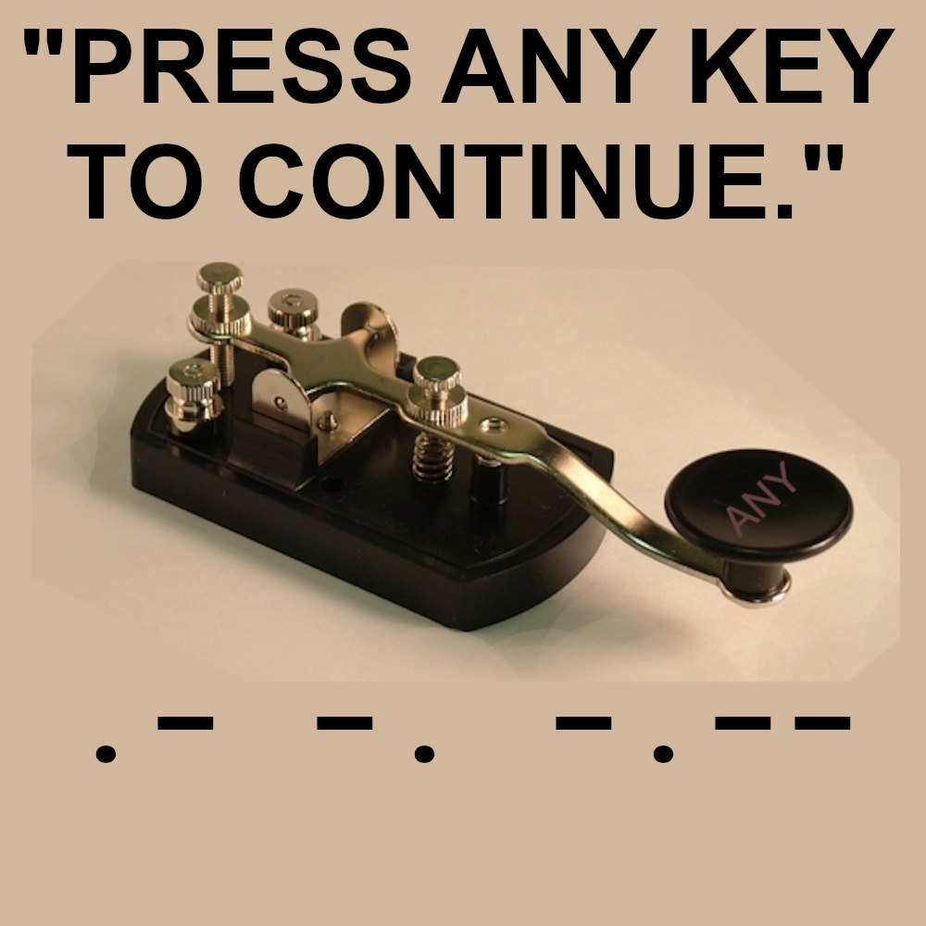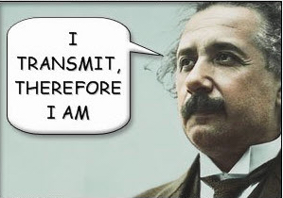

ARES and CERT: The radio amateur, especially an ARES-registered operator, is the ideal candidate for forming and leading a neighborhood Community Emergency Response Team. A critical part of the CERT's planning and operations is radio communications, and we as radio amateurs have the experience and credibility for this emergency support function out of the gate. Become a CERT leader! Every journey of recruiting a dozen homes on a street for a CERT begins with the first, perhaps your next door neighbor. Talk to him or her "over the fence" and start planning and drafting your team. Read and use the FEMA publication CERT User Guide. There are many resources to help you! You can start with FEMA's Independent Study Course on CERT. A reader recently called my attention to a new library of disaster-related training with numerous videos, including several on Neighborhood Preparedness and Response. I haven't had a chance to review the materials yet, but I will. The library can be accessed at the Just In Time Disaster Training website.
FEMA has a number of resources available to the CERT members and leader. You can get the CERT National Newsletter as well as Search CERT programs by location.
The program coordinators must conduct the CERT Basic Training Course and hold a CERT exercise at least once a year. There must be a point of contact to be posted with other program information on the national CERT website.
Search to find a CERT program in your locale to help you set up and establish your neighborhood CERT. The CERT concept can also be extended to workplaces -- the same ideals apply!

Area Nets (All times central unless otherwise indicated)

Monday
Stoddard County ARES net 2nd Monday monthly, 6 pm 147.150+ 100 pl
The Missouri ARES® District E Training and Traffic net 7 pm on 147.330 pl tone 100.0 (Bloomfield)
Missouri DMR Net 7 pm on talk group 31291
SEMO ARA Butler Co ARES check-in net at 7:30 pm on 145.350 pl 100.0
Missouri DMR Net 7:30 pm on talk group 3129
SEMO ARA Butler Co ARES net at 8 pm on 146.910 pl 100.0
Missouri DMR net 8pm TG 3129

Tuesday
SEMO ARA Learn Morse Code Net about 5:30 pm on 146.495
Piedmont Net at 7 pm on 147.375 pl 100
Current River net 7:30 pm on 146.865 pl 100

Wednesday
SEMO DMR rag chew 6:30pm talk group 31295

Thursday
The Missouri ARES® District E Training and Traffic net 7 pm on the 146.910 pl tone 100.0 (Poplar Bluff)
Greenville Net 8 pm on 145.230 pl 123
Bootheel ARC, Kennett Net 8 pm on 146.985 pl 100
Digital Thursday net about 8:15 pm on 145.13 & 145.31(no pl tone needed)

Friday
SEMO ARA Learn Morse Code Net about 5:30 pm on 146.495

Sunday
The PBW-Net humanitarian 8 pm on simplex 146.495
SEMO ARA Learn Morse Code Net about 8:15 pm on 146.495
SEMO Emergency Net 7 pm first Sunday each month 28.400 USB

FORMAL TRAFFIC, TRAINING or ROLL CALL NETS (must have a general or higher license)

Missouri Traffic Net nightly 5:30 pm 3.963 (5 pm winter hours)
Missouri Emergency Services Net 2 pm Sunday on 3.963 MHz+/- or 7.263 MHz +/-
Illinois Sideband Traffic Net nightly at 6 pm on 3.905
Illinois ARES net First and Third Sunday 4:30pm 3.905
Arkansas Razorback Traffic net nightly 6:30pm 3.987.5
Country Cousins Net. Daily 8:30 pm 3.970
Ham Butchers. weekdays 11:30 am. 7.280
Frisco Net. Saturday. 9 am 3.922 or 3.915 depending on conditions
Kadiddlehoppers daily (except Sunday) 12:30 pm 7.253.5

NOAA emergency radio frequencies: 163.275, 162.55, 162.525, 162.50, 162.475, 162.45, 162.425, 162.40
Remember our Ice Cream Social (dutch treat) at Burger King the 4th Tuesday evening each month at 6:30pm.

Emergency radio frequencies you may need at one time or another:
- 163.5125 – Military national disaster preparedness frequency
- 163.4875 – National Guard emergency communications frequency
- 156.80 – International maritime distress channel
- 156.75 – International maritime weather alerts
- 155.475 – Emergency communications for police
- 155.160 – Used by various agencies during search and rescue operations
- 154.295 – Used by firefighters during emergencies
- 154.28 – Used by firefighters during emergencies
- 154.265 – Used by firefighters during emergencies
- 138.225 – Disaster relief channel used by FEMA
- 121.50 – International frequency for aeronautical emergencies
- 47.42 – Nationwide Red Cross channel during humanitarian aid missions
- 39.46 – Inter-department emergency communications by police
- 34.90 – Nationwide National Guard frequency during emergencies

Training for EMCOMM is available here: http://www.arrl.org/emergency-communications-training

One way to communicate with family members during an emergency situation when cellphones are not working is through CB (Citizens’ Band) radio. No license is needed to send or receive communications. Combined with a family disaster plan, it will aid you greatly if cellphone towers stop working. There are 40 separate channels that CB radios operate on. The only one to avoid is Channel 9, which is reserved for the Emergency/REACT channel.
One thing to keep in mind is that your conversations while using CB radio will not be secure. Bad guys could be on the same channel at the same time.
Among the other channels are:
- Channel 37 – Unofficial Prepper 37 (USB)
- Channel 36 – Unofficial Survivalist network
- Channel 19 – Used by truckers headed east or west
- Channel 17 – Used by truckers headed north or south
- Channel 13 – Typically used within campgrounds and marine areas
- Channel 4 – Unofficial American Preppers Network
- Channel 3 – Unofficial Prepper CB Network

Download the ARES® manual at: www.arrl.org/files/file/Public%20Service/ARES/ARESmanual2015.pdf
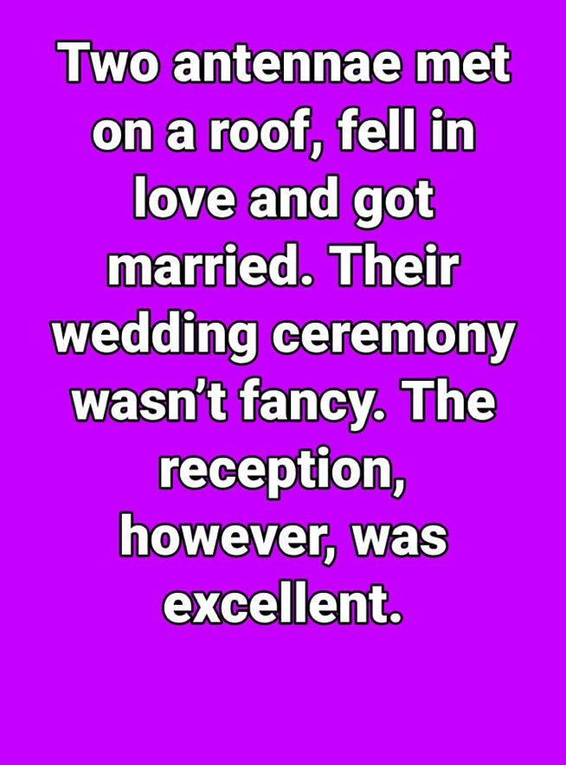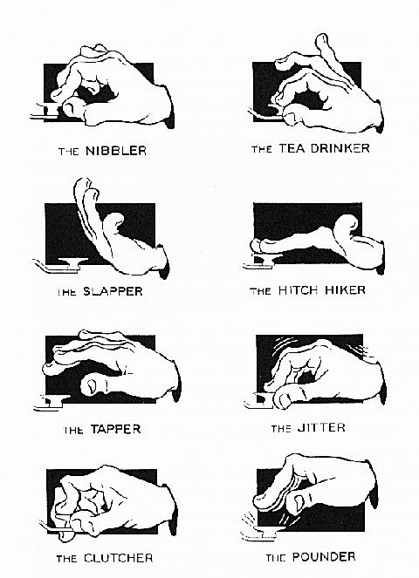

NOTEWORTHY WEBSITES
NWS SKYWARN SPOTTER TRAINING schedule weather.gov/pah/spottertraining
SEMO Amateur Radio Association SEMOHAMS.NET
Topographical Maps heywhatsthat.com
W0AVQ’s Repeater Overlay on Google Earth http://hamradio.w0avq.org/repeaters
ARRL Hamfest and Convention list arrl.org/hamfests/search
Ed’s (AD0WN) Tri-State Repeater list http://semoarc.com/nets.htm
SARA CLUB w9rnm.org
TRI STATE AMATEUR RADIO SOCIETY w9og.net
W9RY SOUTHERN IL. AMATEUR RADIO PAGE w9ry.com
TRI STATE AMATEUR RADIO SOCIETY w9og.net
CountyHunter.com for cw
Weather forecasting related Windy.com

Plan for emergencies at ready.gov and providentliving.org, emergency.cdc.gov, fema.gov, redcross.org/get-help/how-to-prepare-for-emergencies.html, savethechildren.org/us/what-we-do/us-programs/disaster-relief-in-america

We are in need of sponsors for our fund raisers. A sponsor may support us with gift certificates or monetarily. Talk to business owners you know and see if they are interested in helping the community by supporting SEMO ARA. They will be mentioned often in our newsletter and on our Facebook pages. We are open to ideas.

Do you have an item for the News Letter? Email it to KC9NNT@ARRL.NET

Answer to test your memory: B. I = E / R

